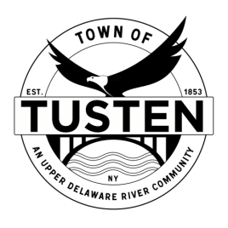
Regular Meeting Agenda
July 25, 2023

OPENING ITEMS ~

Call Meeting to Order at 7:30 PM

Pledge of allegiance

Minutes
- Accept Minutes from March 2023
- CORRESPONDENCE

OLD BUSINESS

NEW BUSINESS
- Steve Miss, 22 Skipperene Road, Narrowsburg NY for special use permit SBL 1-1-21.6
- Anthony Marsanico & Janet Sgritto, Lake Shore Road, for subdivision
SBL 15-12-2 & 5-1-13.1
- Kathryn Andrews, 96 Kirk Road, Narrowsburg special use permit for Dog Wash SBL 8-2-5.2
- JMP Enterprises, State Route 97, Narrowsburg, NY for Lot combination SBL 18-1-30 & 18-1-32

Motion to set Public Hearing(s) for (if applicable):

CLOSING ITEMS

Board Comment

Meeting reminder

Adjournment

