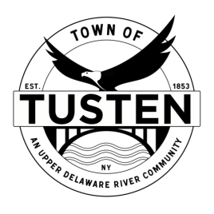Regular Meeting Agenda

September 12, 2022
7:30 M

OPENING ITEMS

Call Meeting to Order at 7:30PM

Pledge of allegiance

Minutes
- Accept Minutes from August 8, 2022

OLD BUSINESS
Eagles Nest Subdivision, 437 Hankins Road, Narrowsburg NY for an area variance

NEW BUSINESS
NA

SET PUBLIC HEARING (S) ~ if applicable

Motion to set Public Hearing(s) for:

CLOSING ITEMS

Board Comment

Meeting reminder

Adjournment

